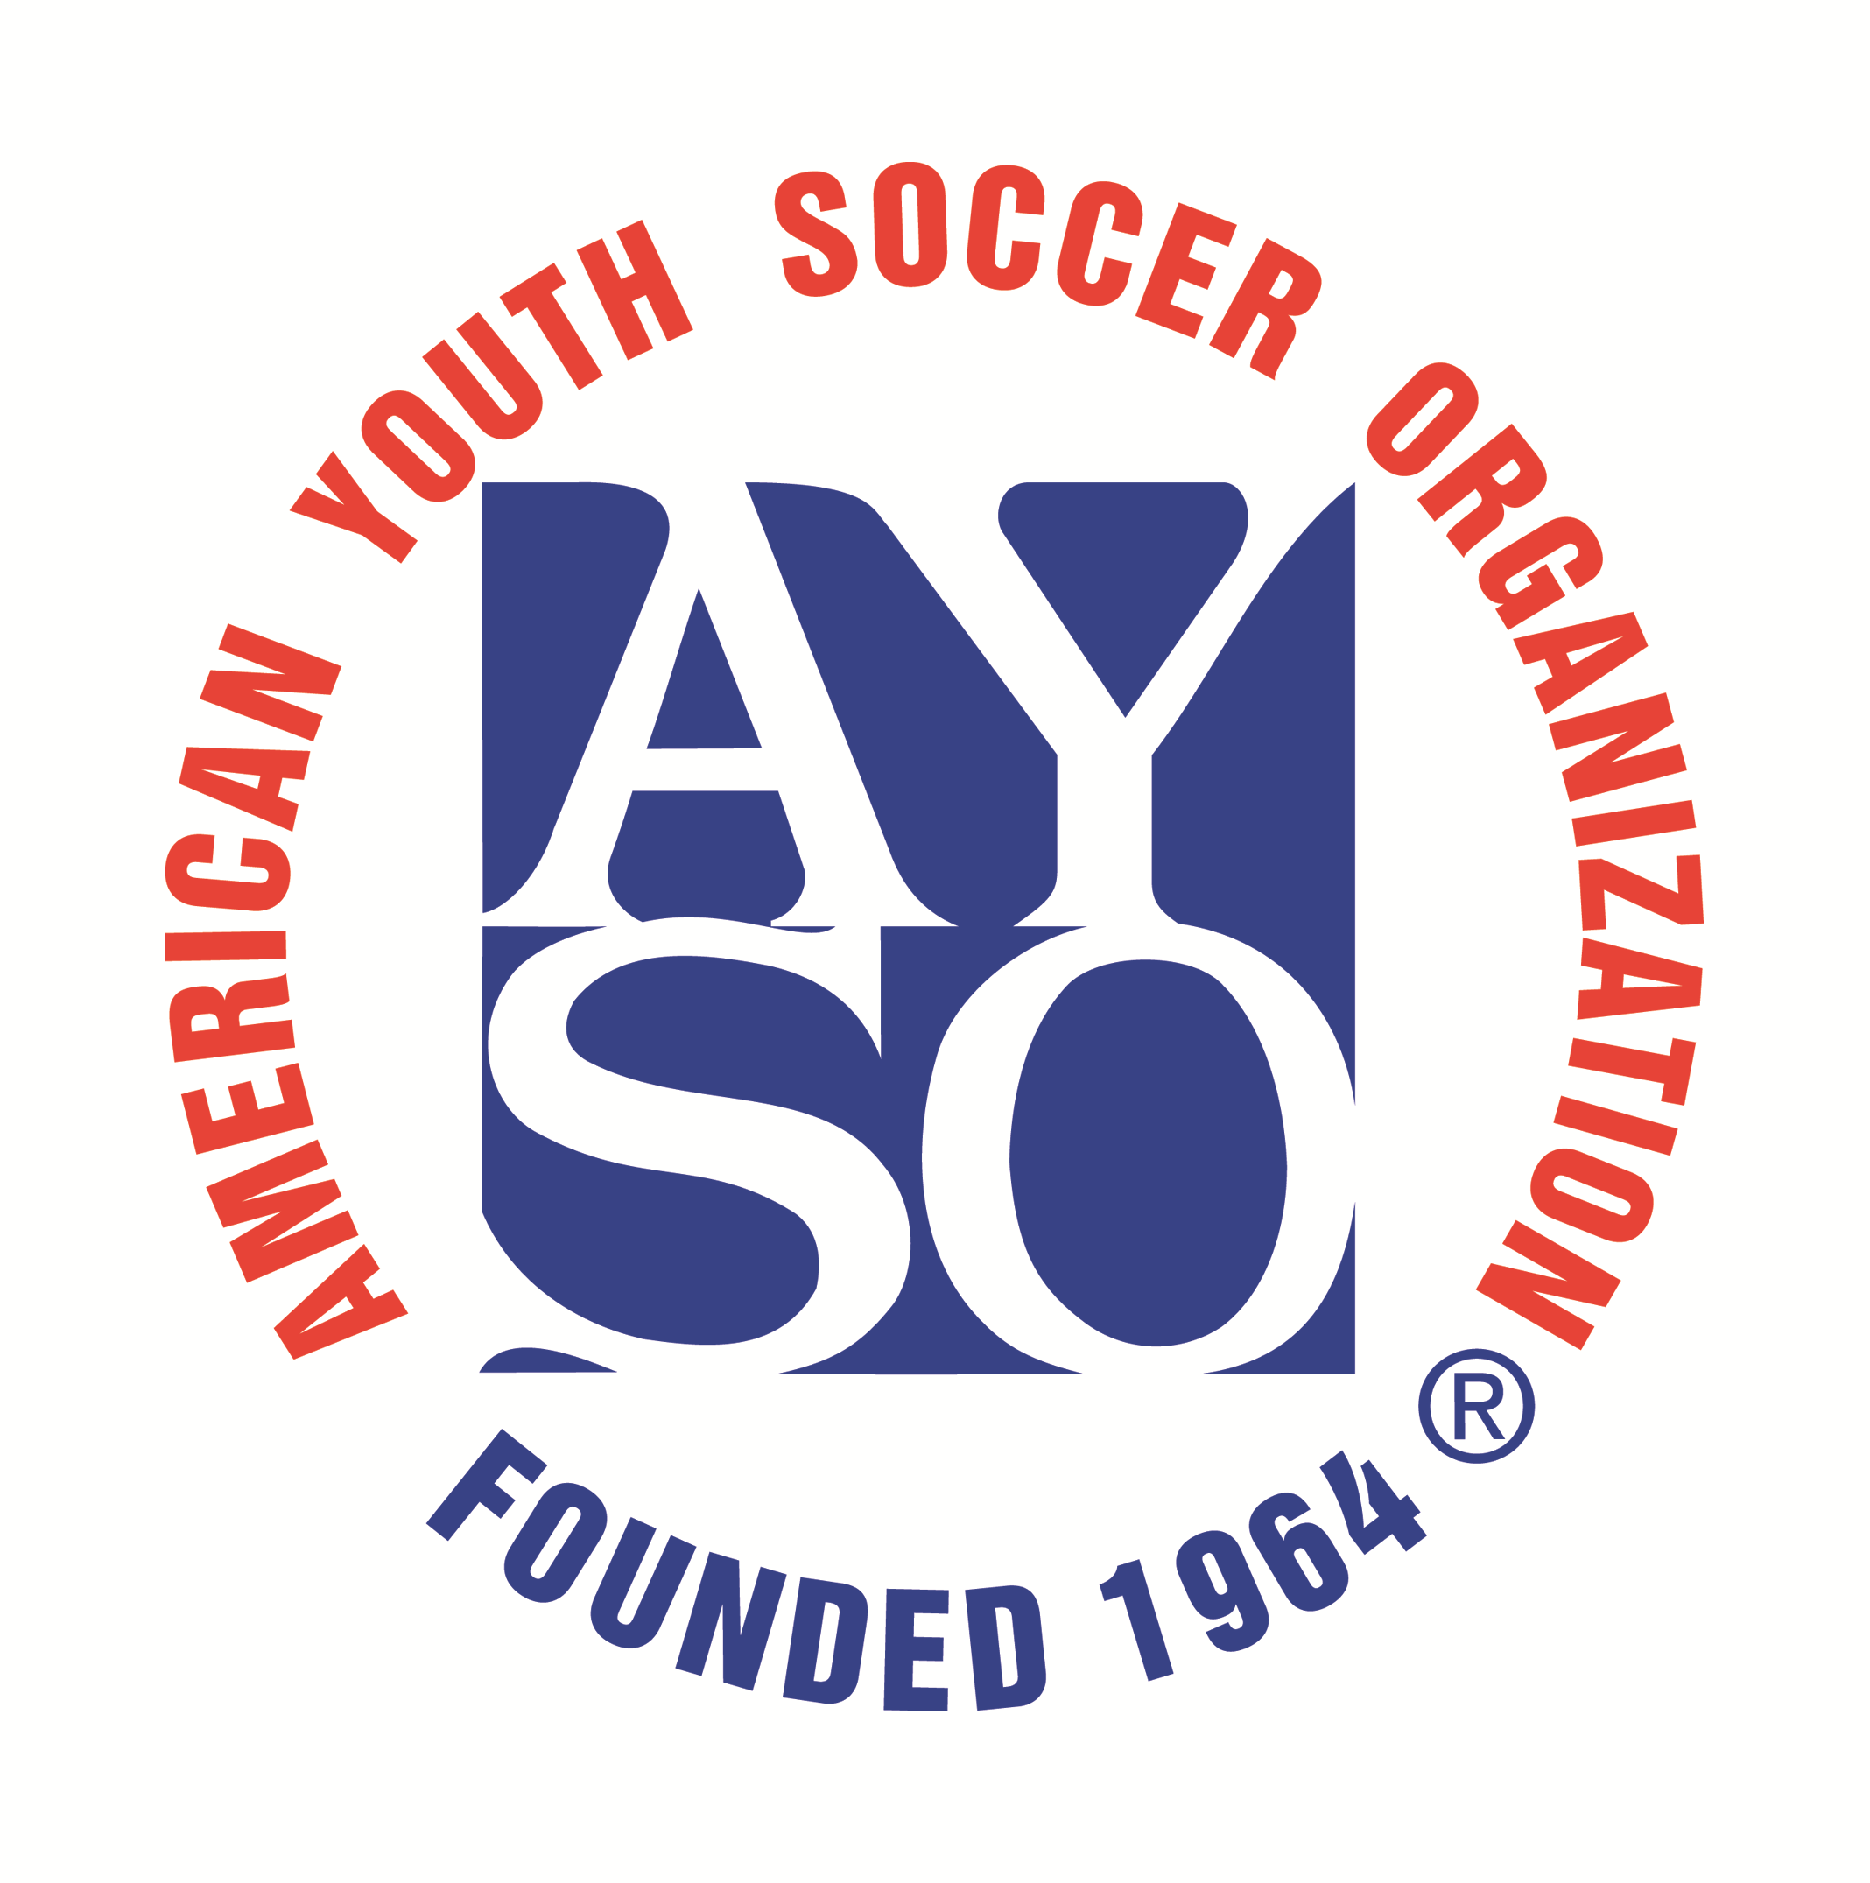
Whew! I’ve registered!
Now what happens?

What’s the Board doing?
Immediately after the last registration date, your Region Board begins the process of putting the teams together for the upcoming season. When this is completed, the uniforms will be ordered and the coaches will be notified.

When do the coaches get their teams?
Coaches should expect to receive their team rosters by the end of May. If we’re running late, it means we’re still looking for coaches!

When do the players get called?
Teams usually begin practice the first or second week of June. Coaches will call families and give you all the information you will need in regards to practice times and location. Each coach sets his/her own practice days, time and location. Practices will take place at city parks, not at Siebel Soccer Complex (except 6U division teams).

It’s after June 1st, and my child has not been called. What do I do?
Please do not panic if you see teams practicing and your child has not been called. Not all teams begin practice at the same time. The very young teams, in particular, do not practice before June 14th as their practices take place in the first 30 min of their game slot. Also some coaches may be out of town. If your child has not been called by June 6, please email us at aysogf674@gmail.com

What else does my child need?
The registration fee includes: complete uniform (jersey, shorts, socks) and supplemental accident insurance. Your child may need to obtain shoes, shin guards, a soccer ball (size depends on age) and a water bottle is a must for every practice and game!

How often are practices and games?
Practices are at the discretion of the coach, typically 1-2 per week (field and times to be determined by your child’s coach). Games will be on Tuesdays/Thursdays with the first games starting June 14. Games and practices will be held at a field at the Siebel Soccer Complex.

Refund?
As stated during registration, AYSO-Great Falls does not offer player refunds except in exceptional circumstances. Any refund requests should be addressed to the Regional Commissioner at aysogf674@gmail.com

Late registration?
There is NO late registration but you can contact us to ask to be put on a waiting list (no guarantees of placement).

Please Remember…
AYSO is a parent-based volunteer organization established to provide a positive experience for our children. Go to the games. Learn the rules. Above all, be tolerant of the children’s coaches and referees mistakes and weaknesses.

Questions?
Contact us through our Facebook page: https://www.facebook.com/AysoRegion674GF by email: aysogf674@gmail.com or check the Region Web site: https://www.ayso674.org/

